
NORTHERN EDUCATION DIVISION MOCK EXAMINATION
2026 MALAWI SCHOOL CERTIFICATE OF EDUCATION
MATHEMATICS
Subject Number: M131/II
Monday, 23rd March Time Allowed: 2h 30min
8:00 - 10:30 am
PAPER II
(100 marks)

Instructions:
- This paper contains 16 printed pages.
Please check.
- Answer all the six questions in Section A
and any four questions in section B.
- The maximum number of marks for each answer is indicated against each question
- Write your answers in the spaces provided on the question paper.
- Scientific calculators may be used.
- The graph paper and blank answer sheet at the end of the question paper can be used if required. Do not tear them off.
- All working must be clearly shown.
- Write your Examination number at the top of every page
Question  Number | Tick if answered | Do not write in these columns
1
2
3
4
5
6
7
8
9
10
11
12

Turn over
- a. Without using a calculator, simplify $\frac{12\sqrt{5}}{2 \sqrt{5}-4}$, leaving your answer with a rational denominator. (4 marks)

b. Simplify $\frac{{3x}^{3}}{{3x}^{2}-6xy}+\frac{{4y}^{3}}{{2y}^{2}-xy}$ (5 marks)

- a. Two similar cylinders A and B have heights of $4cm$ and $6cm$respectively. If the volume of the cylinder A is ${50cm}^{3}$, find the volume of the cylinder B. (4 marks)

b. Given that $μ=\{1,2,3,4,5,6,7,8,9.10\}$. A$=\{$perfect squares$\}$, B$=\{$multiples of 3$\}$ and C$=\{$prime numbers$\}$. Find ${(A∪B∪C)}^{'}$ (5 marks)

- a. Figure 1 shows a triangle ABC such that $AB=\left(x-3\right)cm,BC=\left(x+3\right)cm, AC=8cm$ and angle $BAC={60}^{0}$.
C

$$\left(x+3\right)cm$$
8 cm

$${60}^{}$$
B
A
$$\left(x-3\right)cm$$
Find the value $x$. (5 marks)

b. Figure 2 shows a rectangular based pyramid PQRST with vertex T vertically
above the midpoint M of the side PQ.$SR=24 cm,QR=5cm$ and $TQ= 20cm.$
T
$$24cm$$
R
S
Q
$$20cm$$
$$5cm$$
P

M

Calculate the angle between the RTS ad PQRS to the nearest degree.(5 marks)

- a. Figure 3 shows the speed-time graph of a moving object. Given that the rate at which the object decelerates after $t=15 seconds$ is equal to half the rate at which it accelerates during the first $6$ seconds.
Speed

$$40$$
(m/s)
$$16$$

Time (s)
$$0$$
$$15$$
$$6$$

Calculate the time at which it stops. (5 marks)

b. Table 1 shows class intervals of scores and their frequencies

Scores | $$1-20$$ | $$21-40$$ | $$41-60$$ | $$61-80$$
Frequency | $$12$$ | $$28$$ | $$20$$ | $$6$$
Table 1.
Using a scale of 2 cm to represent 5 units in both axes, draw a histogram to
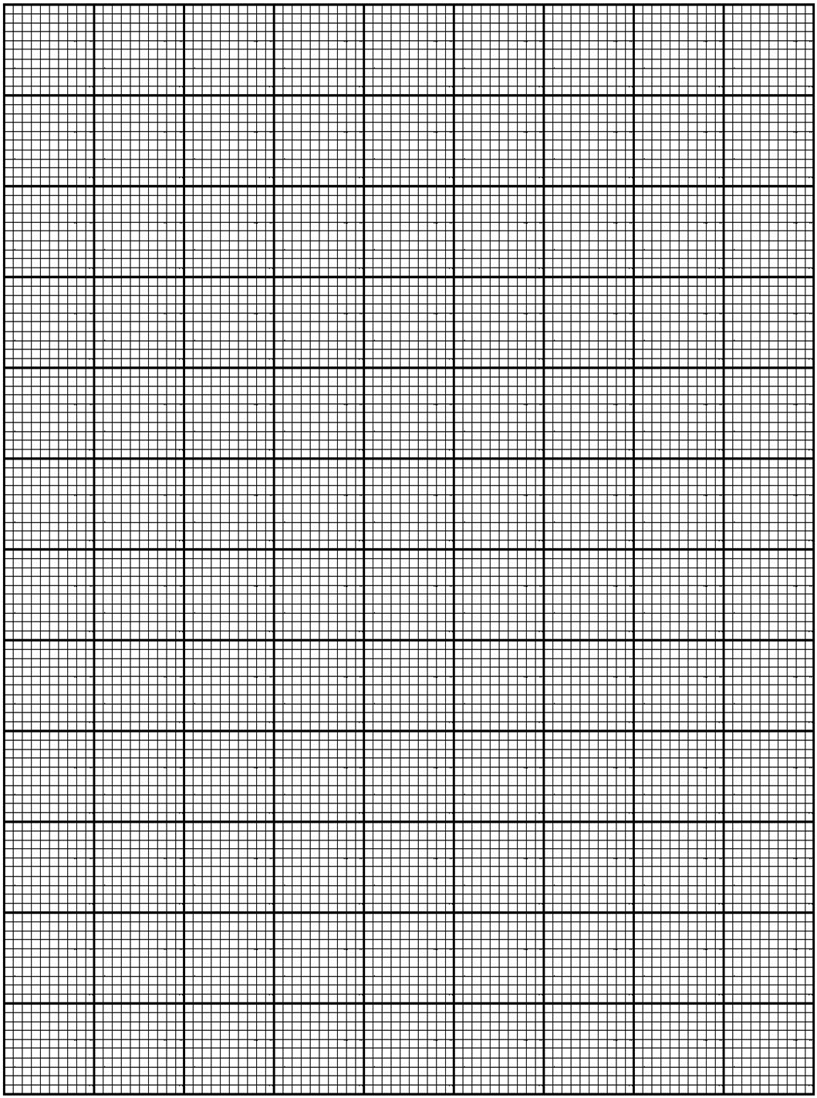
represent this information. (5 marks)

- a. Solve the equation $8 x 2^{2y}=\frac{2^{5y+1}}{4^{-y}}$ (6 marks)

b. Using a ruler and a pair of compasses only, construct in the same diagram:
- a circle centre $O$ of radius $3cm$
- a point R outside the circle such that $OR=10cm.$
- a tangent TR to the circle at R.
- Measure and state the length of $TR$ (6 marks)

- a. Prove the theory which states that opposite angles of a cyclic quadrilateral are supplementary. (5 marks)

b. Figure 4 shows a trapezium ABCD where AD is parallel to BC.$\vec{BD}=5\underline{a}+\underline{b}$,
$\vec{DC}=\underline{a}-10\underline{b}$ and $\vec{AD}=4\underline{a}+k\underline{b}$.
$$4\underline{a}+k\underline{b}$$

A
D

$$\underline{a}-10\underline{b}$$

$$5\underline{a}+\underline{b}$$

C
B

Find the value of $k.$ (5 marks)

SECTION B (40 marks)
Answer any four questions from this section in the spaces provided.

- Solve the following equations simultaneously.
$y=2x+3$
$xy+20=5y$ (10 marks)

- Solve the equation $x^{3}-{3x}^{2}-4x+12=0$ (10 marks)

- The cost of plating articles of a given shape is the sum of two parts. One is fixed, and the other part varies as the square of the height of the article. It costs K370, 000 to plate a $10cm$ high article and K1,120,000 to plate a $20cm$ high article. How high will the article be if it costs K480, 000? (10 marks)

- A small bag contains $4$red and $n$ yellow sweets. Two of the sweets are chosen without replacement from this bag one at a time. If the probability that two red sweets are chosen is$\frac{2}{15}$, find the value of $n.$ (10 marks)

- The manager of a football team has K120,000,000 to spend on buying new players. He can buy defenders at K6,000, 000 each and forwards at K8,000,000 each. There must be at least 4 defenders and at least 3 forwards. To cover for injuries, he must buy at least 10 players altogether.

- Taking $x$ to represent number of defenders and $y$ to represent number of forwards, write down four inequalities in $x$ and $y.$ (4 marks)

- Using a scale $2cm$ to represent 5 units on both axes, draw graphs to show the region represented by the inequalities by shading the unwanted region. (4 marks)

- If the wages are K10,000,000 per month for each defender and K20,000,000 per month for each forward, what is the combination of players which will give lowest wage bill? (2 marks)



- Table 2 shows some values of $x$ and $y$ for the equation $y=3+x-{2x}^{2}$
$$x$$ | $$-2$$ | $$-1$$ | $$0$$ | $$1$$ | $$2$$ | $$3$$
$$y$$ | $$-7$$ |  | $$3$$ | $$2$$ | $$-3$$
Table 2
a. Complete the table of values. (2 marks)
b. Using a scale of $2 cm$ to represent 1 unit on $x-$axis and $2cm$ to represent
2 units on $y-$axis, draw the graph of $y=3+x-{2x}^{2}$. (4 marks)
c. Use your graph to solve the equation $1+2x-{2x}^{2}=0$ (4 marks)


END OF QUESTION PAPER
NB: This paper contains 19 printed pages.

